**Word Sample**

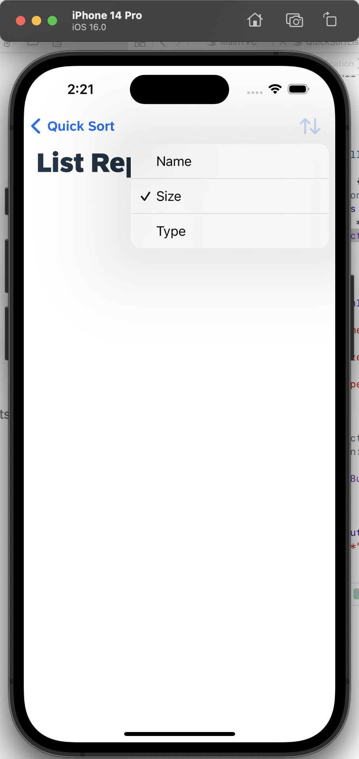image

**Subtitle**

blah, blah, blah, blah, blah, blah, blah, blah, blah, blah, blah, blah, blah, blah, blah, blah, blah, blah, blah, blah, blah, blah, blah, blah, blah, blah, blah, blah, blah, blah, blah, blah, blah, blah, blah, blah, blah, blah.